**Sign In or create a Microsoft Account:**

1. Login to the Microsoft site:

[Microsoft account | Sign In or Create Your Account Today – Microsoft](https://account.microsoft.com/account)

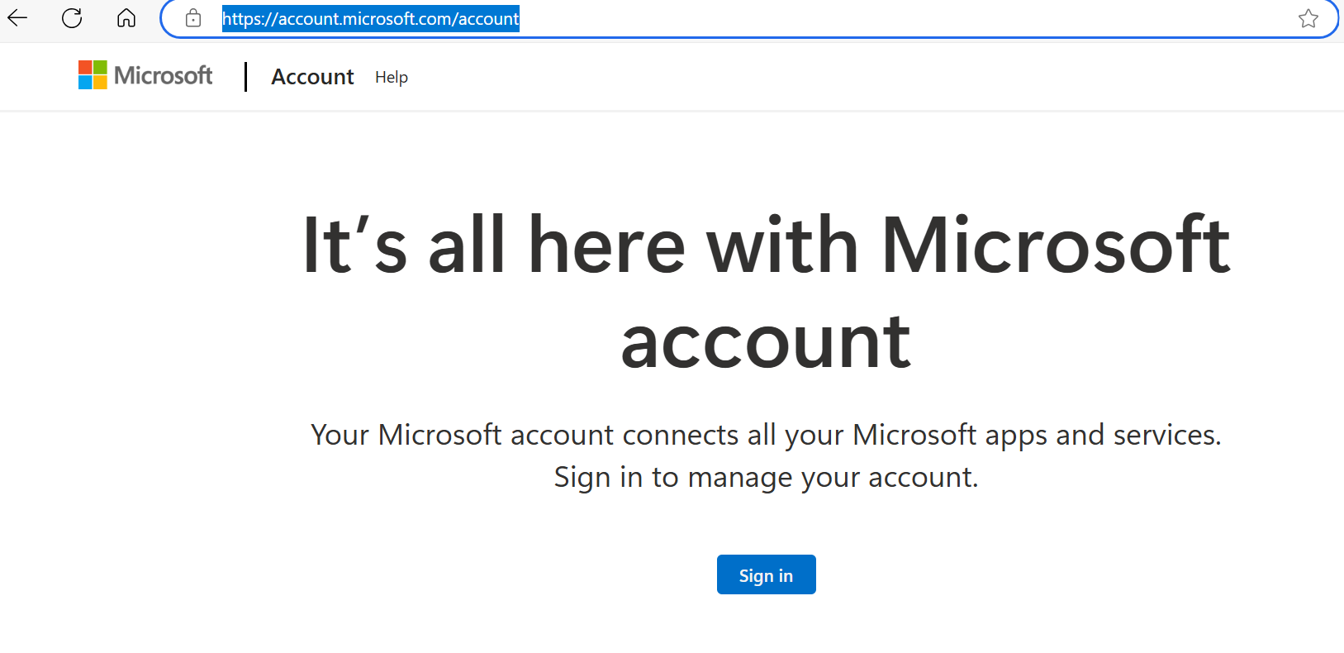

1. Click on ‘Create One’ button.

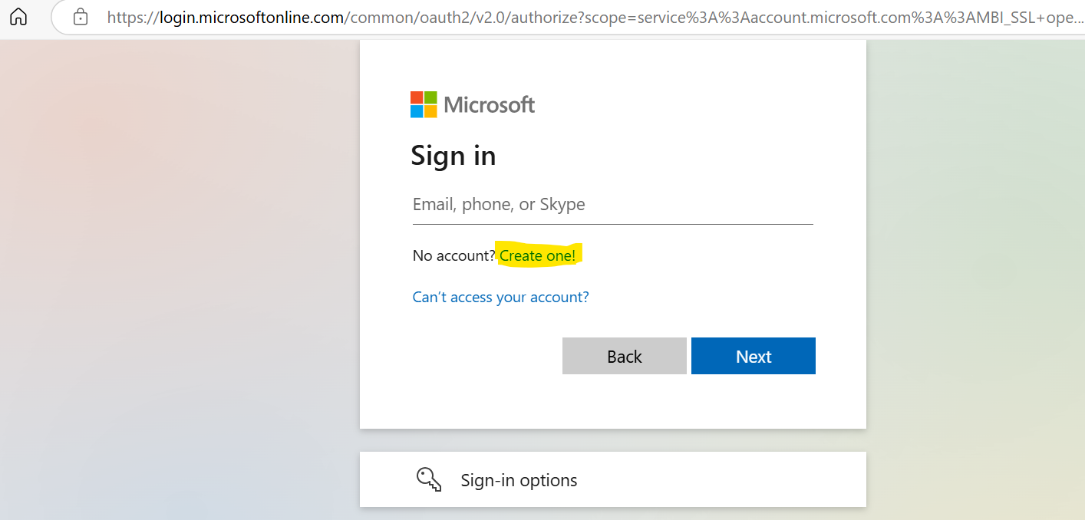

1. Enter an email id already present or provide the new email id created.

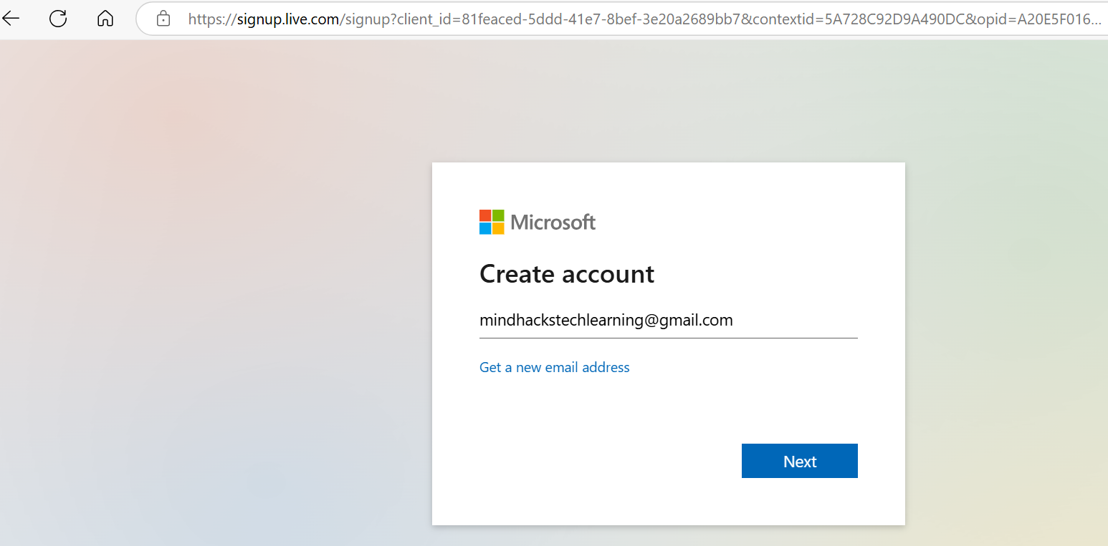

1. Enter the password and then click on the ‘Next’ button.

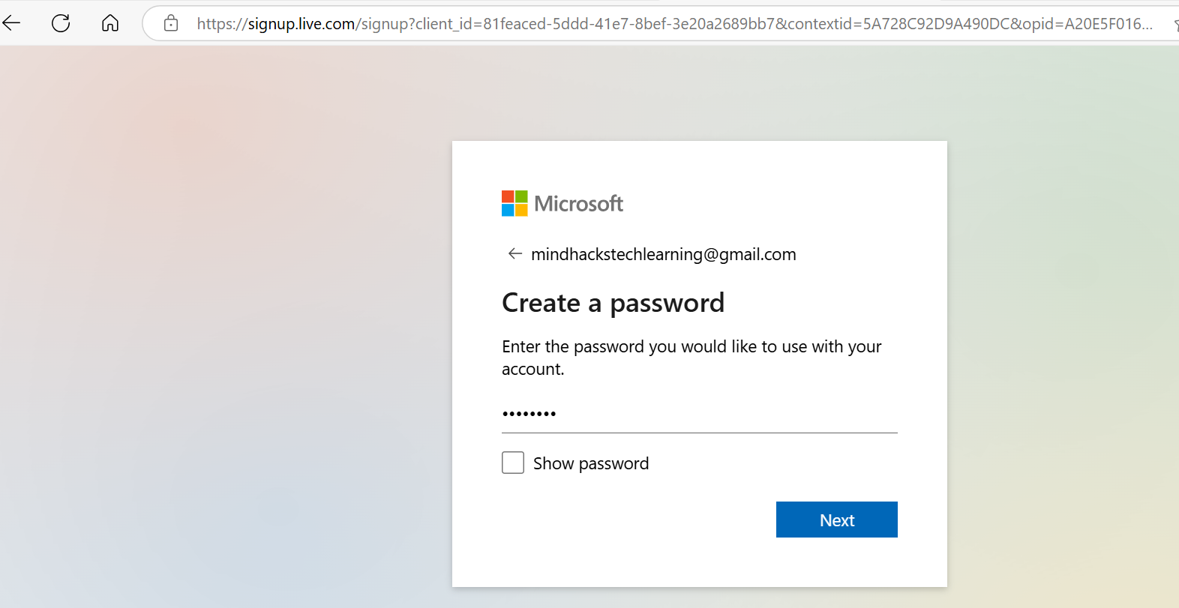

1. Enter the FirstName and the LastName.

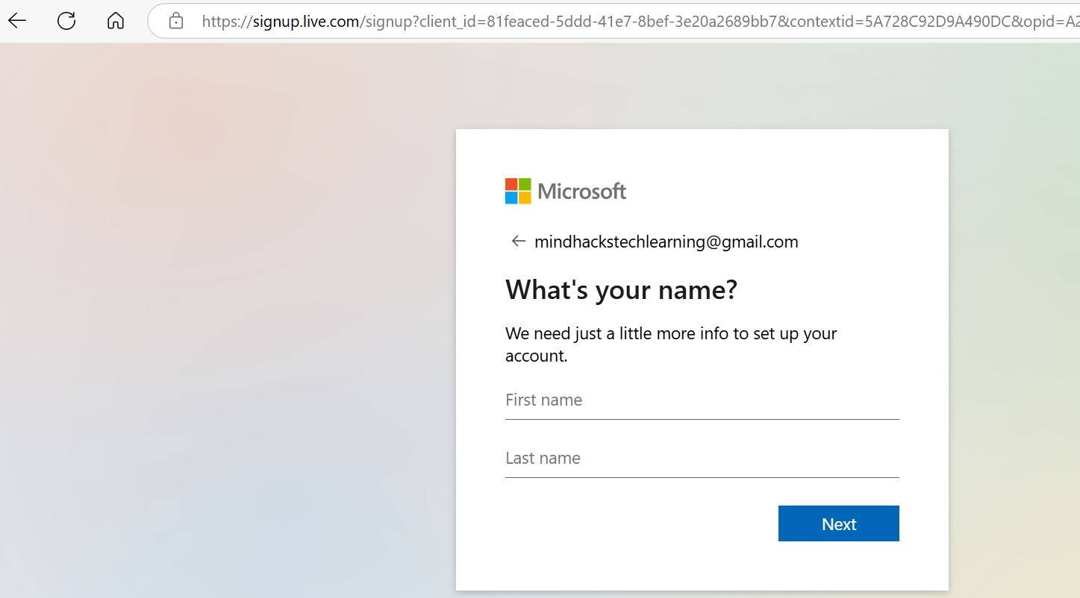

1. Enter the location and date of birth.

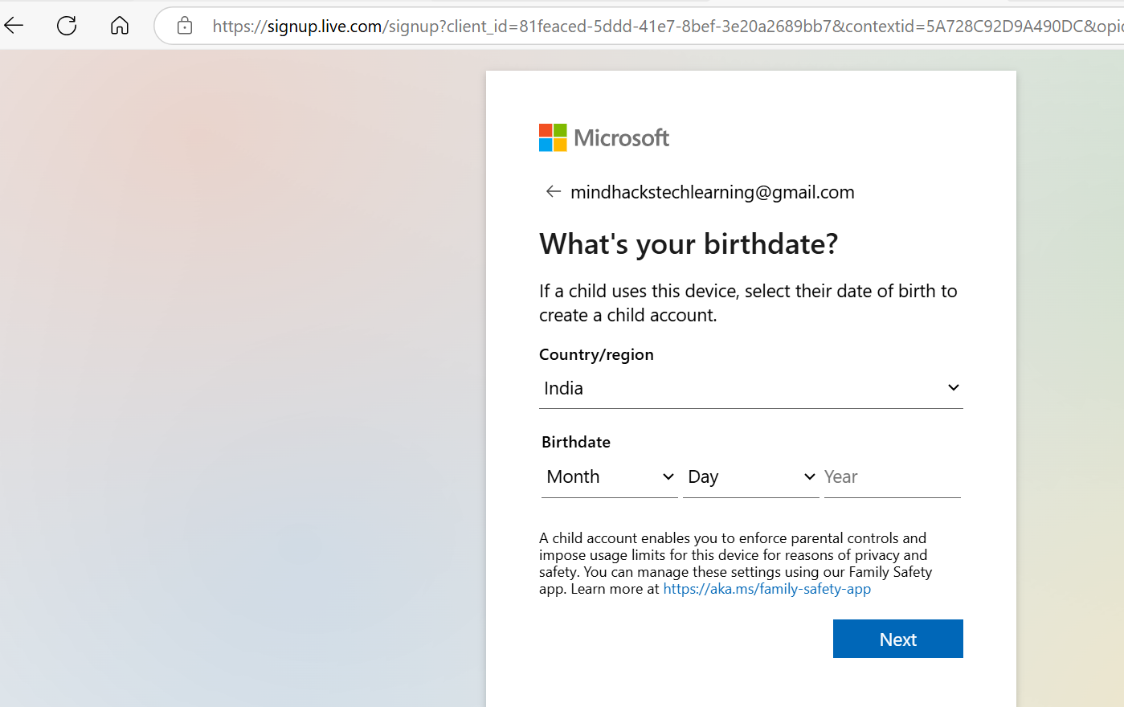

1. Enter the verification code received to your email id.

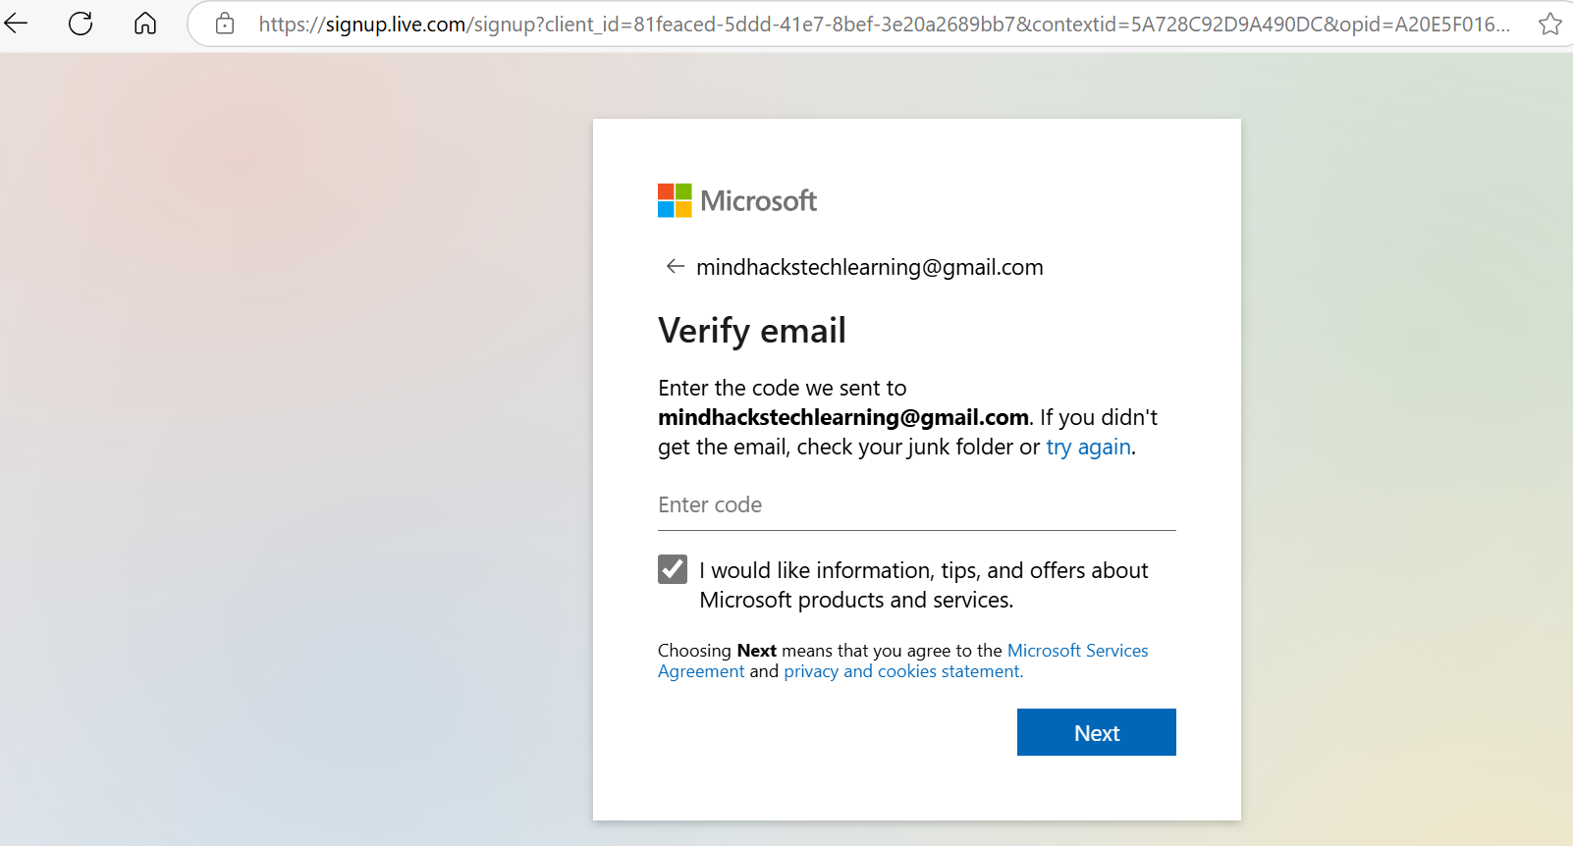

1. The Microsoft account will be created and then we can login by entering the new password that we had created.

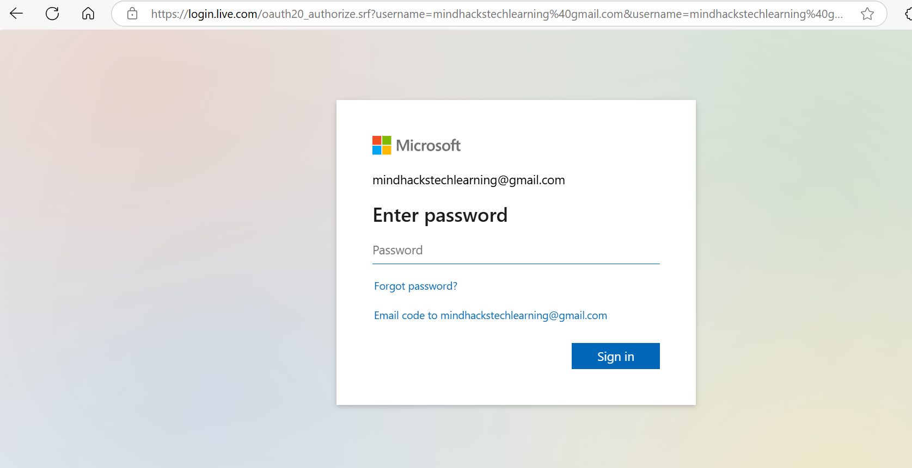

1. Read the privacy notification and then click on Ok button.

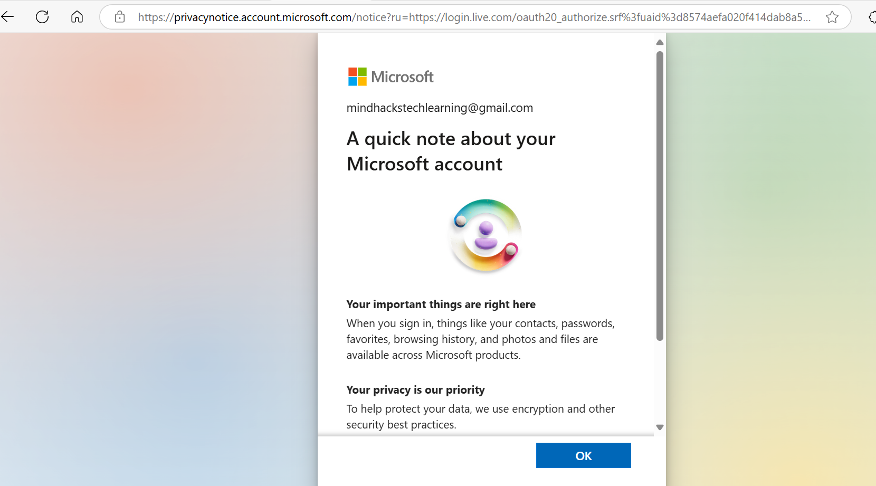

1. Click on ‘Yes’ button:

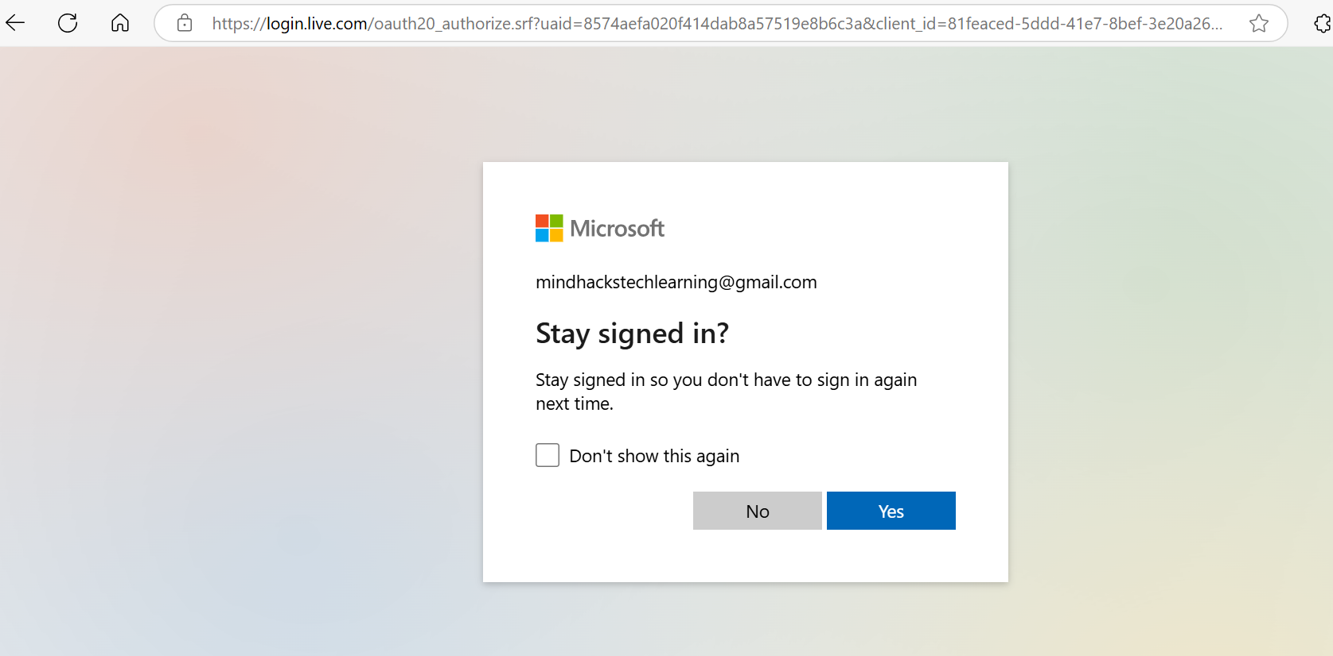

1. The Microsoft account will be created successfully.

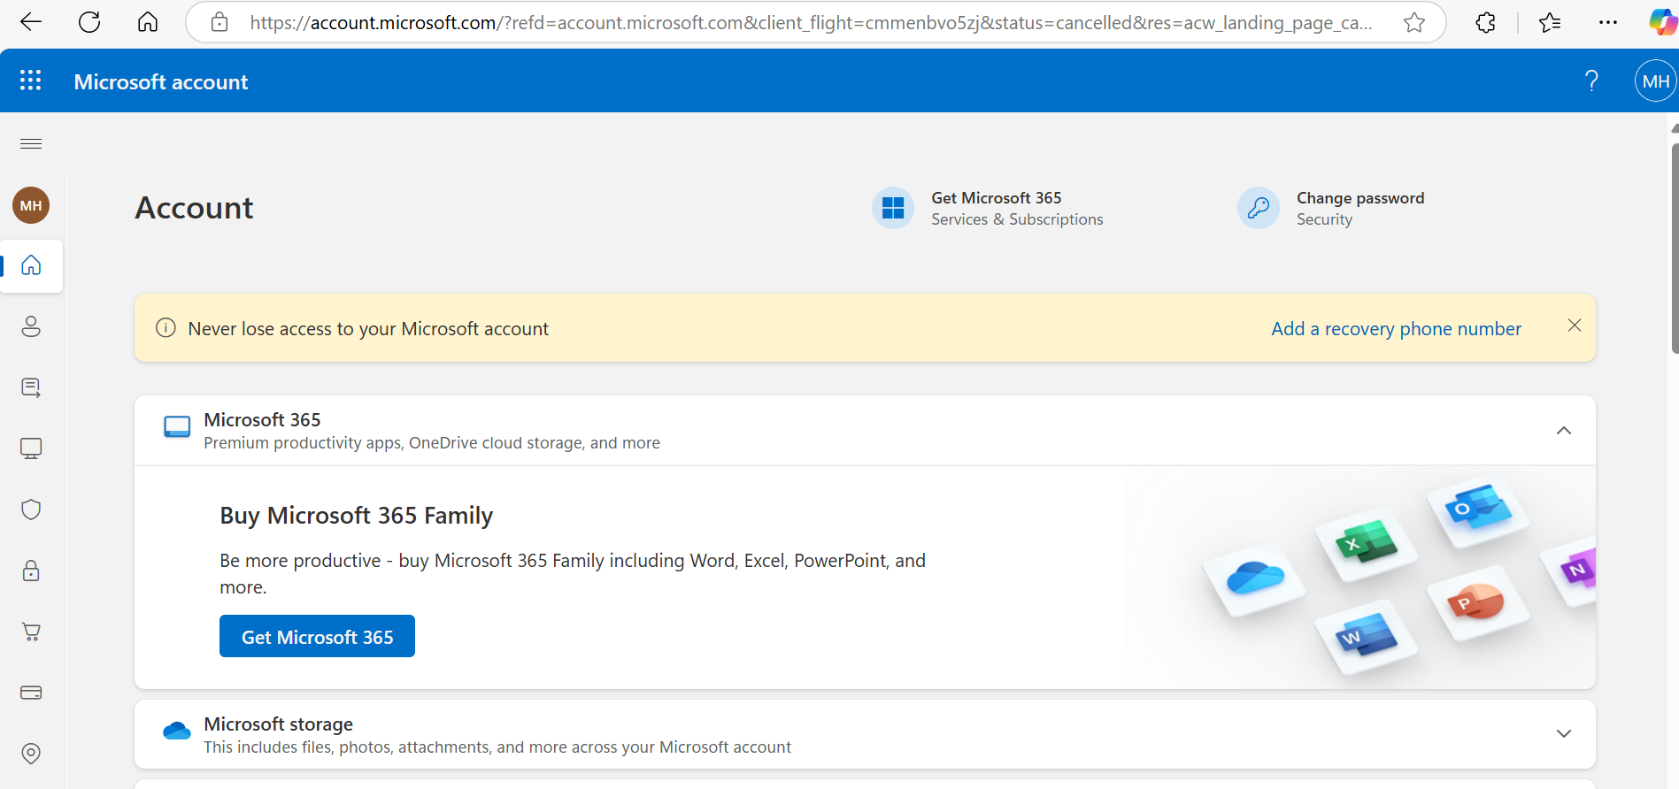

Note: We can use the same account for the Azure Portal login.